**SQL QUERY REPORT**

**-- Total Sales**

SELECT SUM(o.order_quantity * p.price) AS Total_Sales

FROM orders AS o

JOIN products AS p

ON o.product_id = p.product_id;

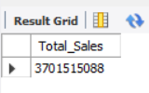

**-- Total Orders**

SELECT COUNT(order_id) AS Total_Orders

FROM orders;

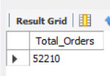

**-- Total Stock**

SELECT SUM(total_stock) AS Total_Stock

FROM products;

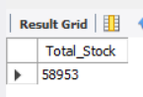

**-- Avrage Rating**

SELECT AVG(customer_review) AS Avrage_Rating

FROM orders;

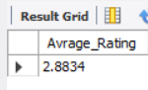

**-- Avrage Price**

SELECT AVG(price) AS Avrage_Price

FROM products;

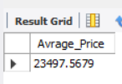

**-- Total Customers**

SELECT COUNT(DISTINCT name) AS Total_Customers

FROM customers;

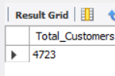

**-- Total Reviews**

SELECT COUNT(customer_review) AS Total_Rewview

FROM orders;

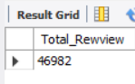

**-- Total Sales by Category**

SELECT p.category, SUM(o.order_quantity * p.price) AS Total_Sales

FROM orders AS o

JOIN products AS p

ON o.product_id = p.product_id

GROUP BY p.category

ORDER BY Total_Sales DESC;

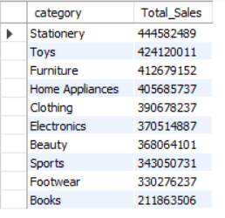

**-- Total Order by Order Status**

SELECT order_status, COUNT(order_id) AS Total_Orders

FROM orders

GROUP BY order_status;

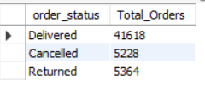

**-- Total Sales by Zone**

SELECT c.zone, SUM(o.order_quantity * p.price) AS Total_Sales

FROM customers AS c

JOIN orders AS o ON c.customer_id = o.customer_id

JOIN products AS p ON o.product_id = p.product_id

GROUP BY c.zone;

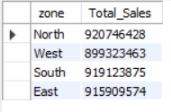

**-- Top 10 Products**

SELECT p.name, SUM(o.order_quantity) AS Total_Orders, SUM(o.order_quantity * p.price) AS Total_Revenue

FROM products AS p

JOIN orders AS o

ON o.product_id = p.product_id

GROUP BY p.name

ORDER BY Total_Revenue DESC LIMIT 10;

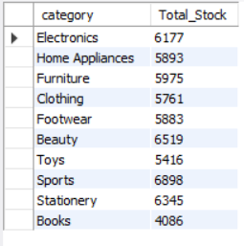

**-- Total Stock by Category**

SELECT category, SUM(total_stock) AS Total_Stock

FROM products

GROUP BY category;



**-- Customer Review**

SELECT customer_review, COUNT(customer_review) AS Total_Reviews

FROM orders

GROUP BY customer_review

ORDER BY customer_review DESC;

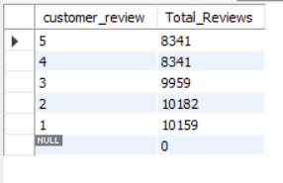

**-- Total Customer by Gender**

SELECT gender, COUNT(gender) AS Total_Customers

FROM customers

GROUP BY gender;

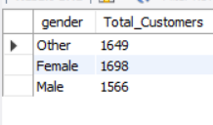

**-- Total Customer by State**

SELECT state, COUNT(DISTINCT name) AS Total_Customers

FROM customers

GROUP BY state;

